**Cloud Computing Experiment 3**

**Name**: Vishwa Mehul Mehta

**SRN**: PES2UG20CS389

**Sec**: F

**Date**: 28-02-2023

1a.

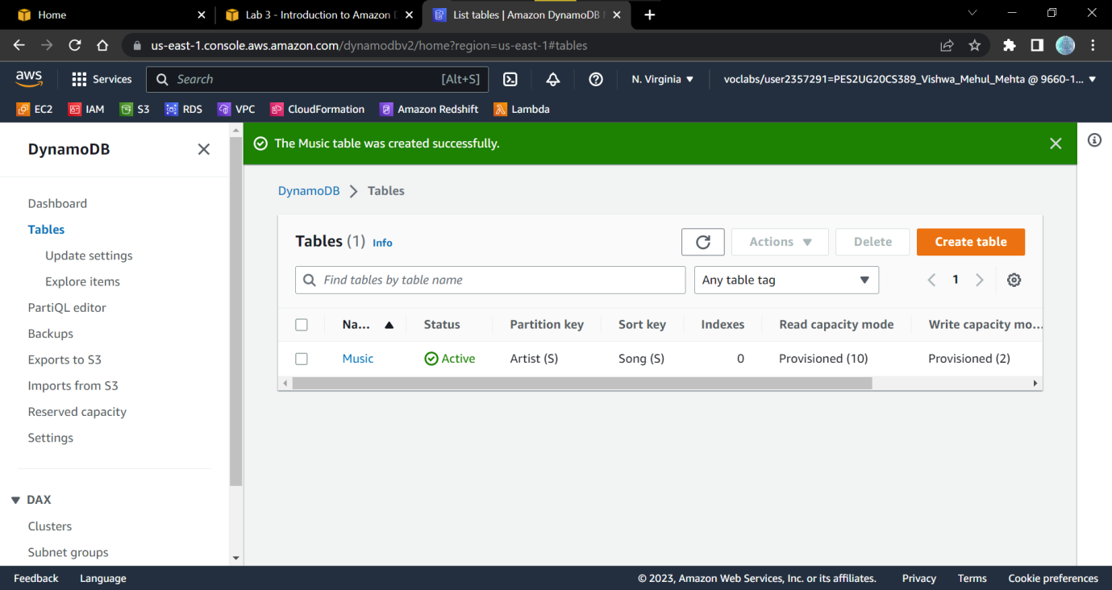

2a.

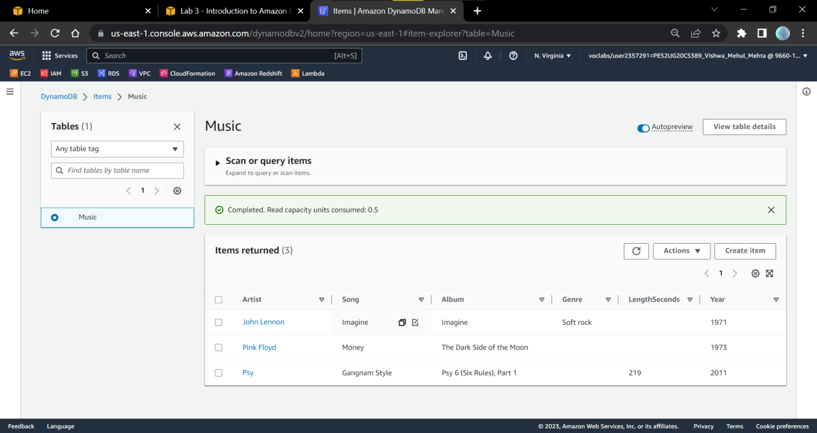

3a.

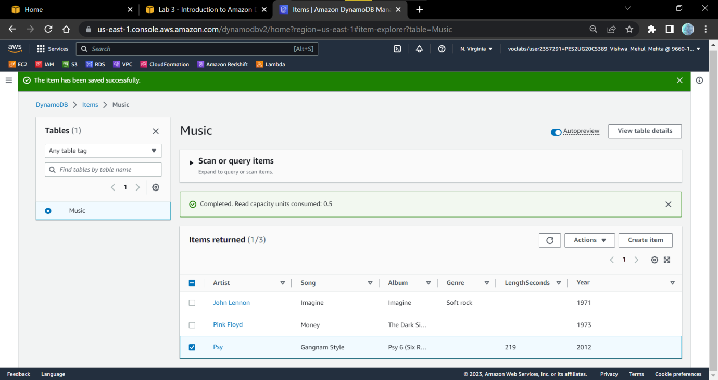

4a.

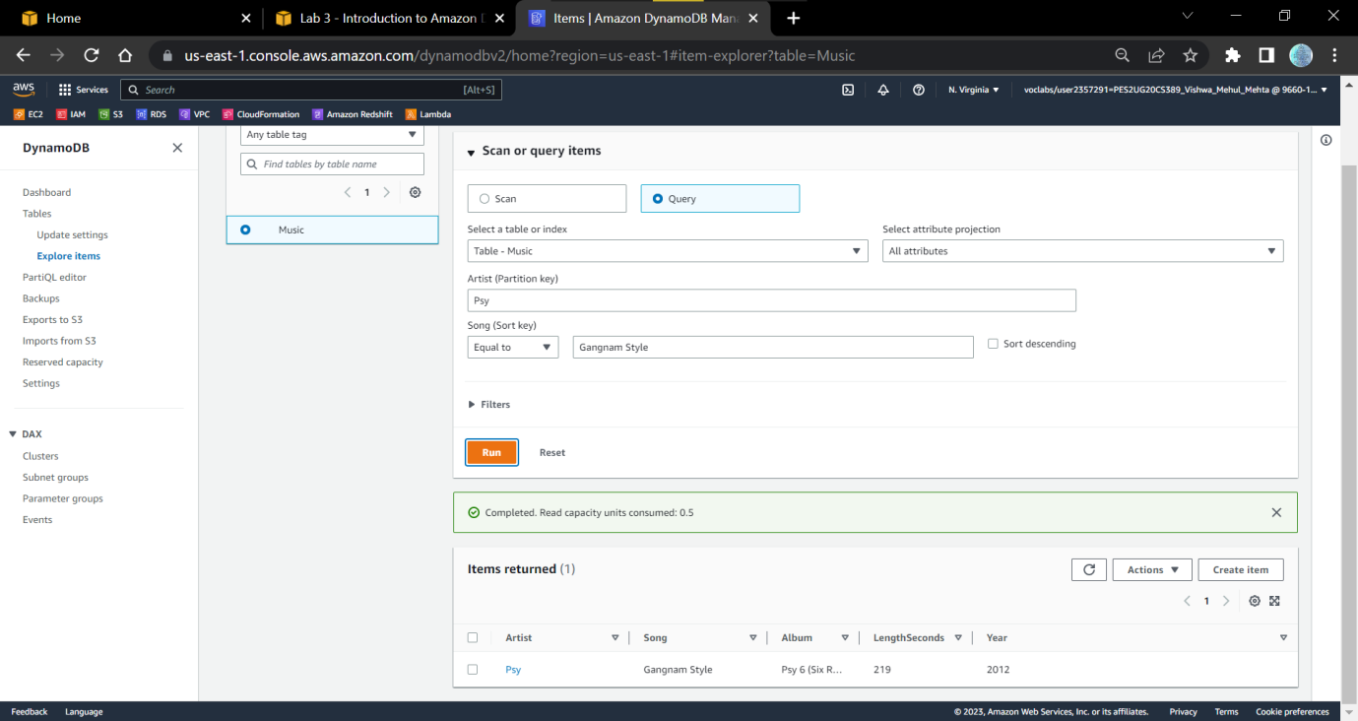

4b.

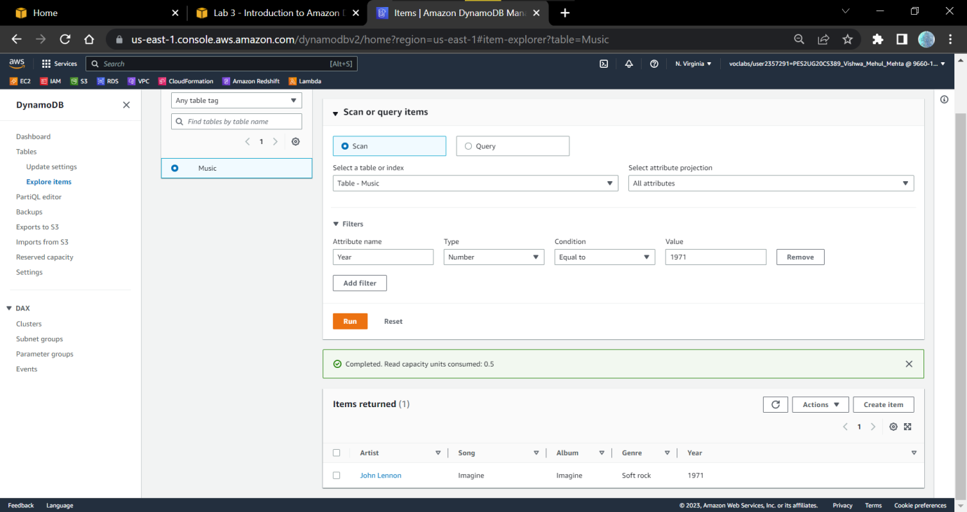

5a.

